CERN Trip Outcomes
The primary purpose of visiting the EP-CMX group at CERN was to characterize the scintillation properties of the CdS nanocrystal embedded epoxy resin samples prepared at UCT, with the aim of identifying the optimal percentage mass concentration of CdS. This involved measuring the transmittance, emission and excitation spectra in the UV-visible range, decay time resolutions time-correlated single photon counting (TCSPC) and decay time resolution (DTR) measurements under pulsed soft X-ray excitation; and coincidence time resolution (CTR) when exposed to a source of back-to-back 511keV gamma radiation.
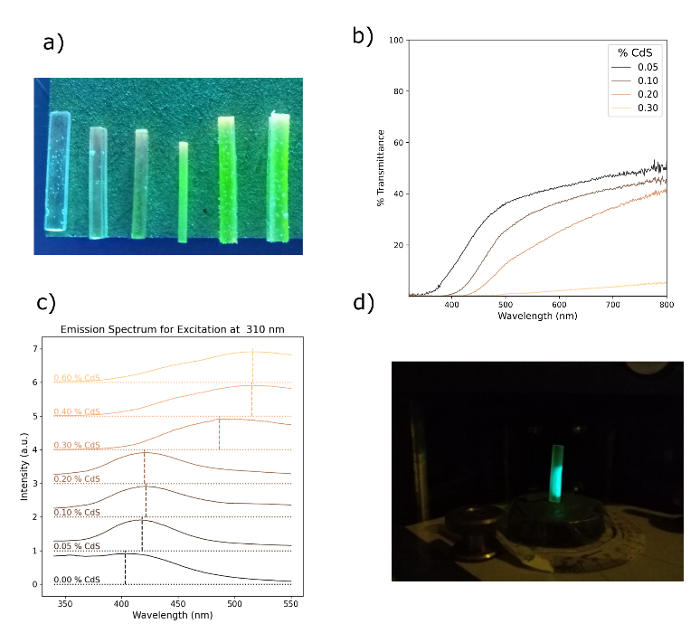
Figure 1: a) CdS epoxy resin samples with %CdS increasing from 0.05 - 0.6 from left to right. Transmittance (b) and emission (c) spectra for increasing CdS concentration samples. d) Sample excitation at 310 nm.
A substantial increase in opacity with increasing CdS concentration was observed in the transmittance measurements in Figure 1.b, which led to broad peaks in the emission and excitation spectra. Encouragingly, strong peaks at 420 nm were observed in the emission spectra under 310 nm excitation for CdS concentrations 0.05% - 0.20% (see Figure 1.c). This is precisely the wavelength required to optimize the scintillation signal of the silicon photomultiplier. Unfortunately, increasing the concentration further resulted in excess secondary scattering and red shift in the emission peak. This made it impossible to discern a coherent signal in the decay time measurements as they rely on high transmittance. However, TCSPC characterisation was more successful as it can be performed in reflection mode. A novel machine learning algorithm was developed to determine the decay times of multiple scintillation components using particle swarm hyperparameter optimization (PSHO), with promisingly fast effective decay time constants < 5ns for all CdS samples (see Figure 2).
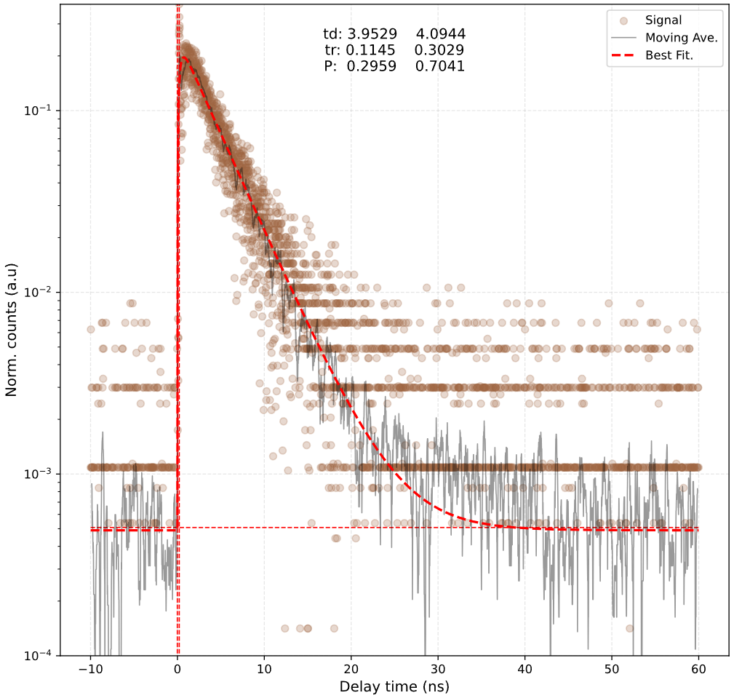
Figure 2: Decay time resolution < 5 ns, fit using PSHO.
Due to a lack of discernible scintillation response to the 511keV gamma rays using the CdS samples, CTR measurements were instead performed using industry standard LYSO crystal samples (see Figure 3), which will function as a vital calibration standard for the new CTR bench being set up at UCT.
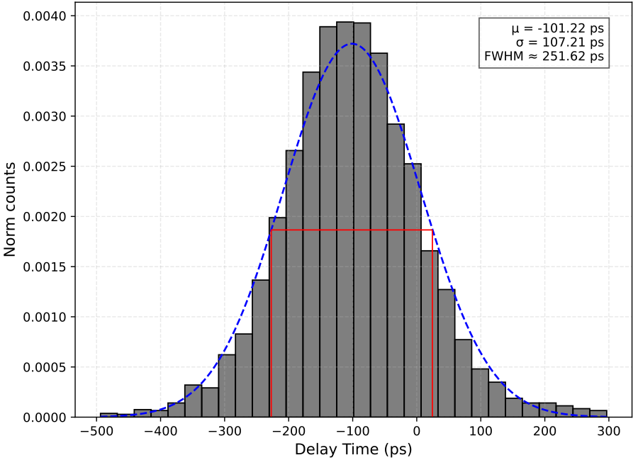
Figure 3: CTR of LYSO for calibration of new UCT bench.

